5.70:
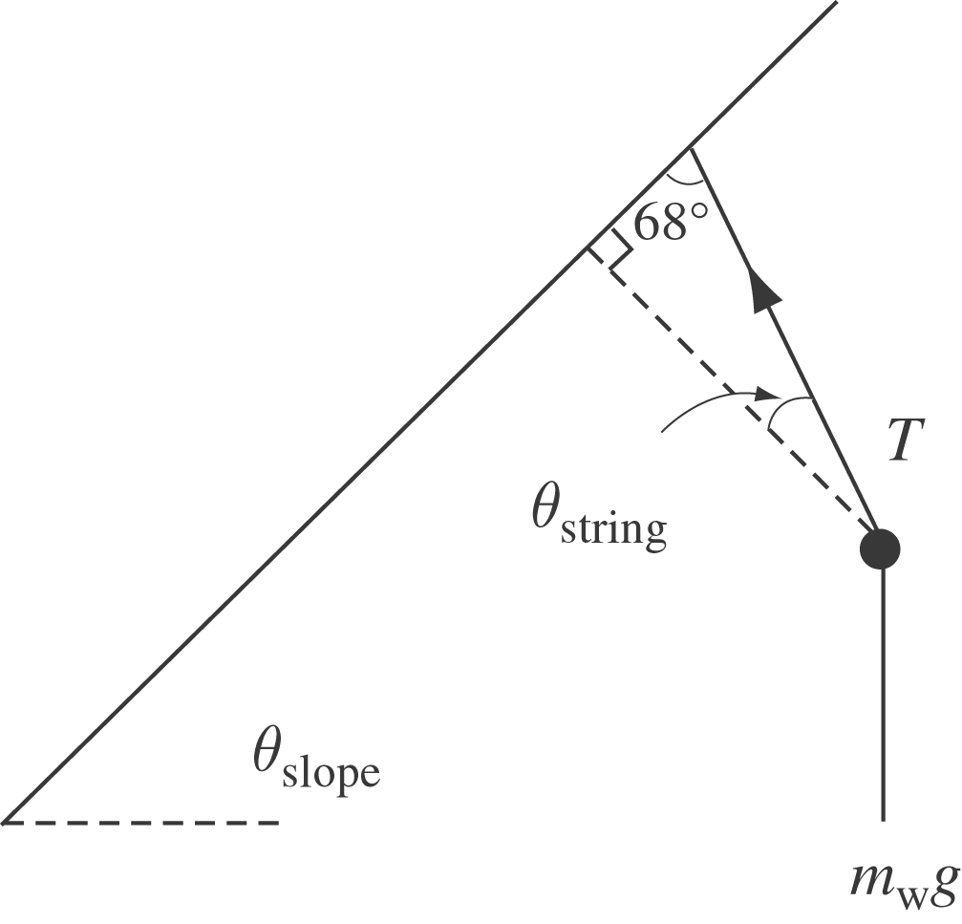

It’s interesting to look at the string’s angle measured from the perpendicular to the top of the crate. This angle is of course 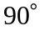—angle measured from the top of the crate. The free-body diagram for the washer then leads to the following equations, using Newton’s Second Law and taking the upslope direction as positive:
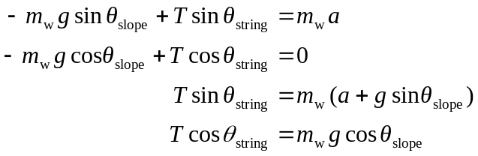
Dividing the two equations:
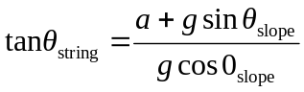
For the crate, the component of the weight along the slope is 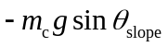 and the normal force is 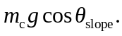 Using Newton’s Second Law again:
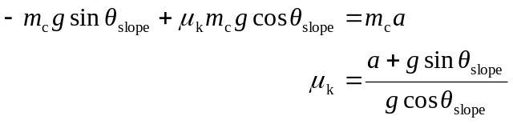
which leads to the interesting observation that the string will hang at an angle whose tangent is equal to the coefficient of kinetic friction:

